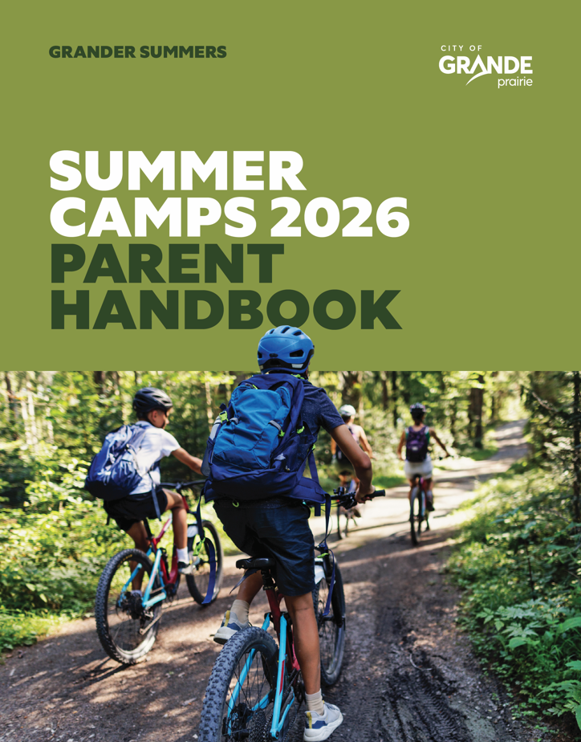

CHILD AND YOUTH
PROGRAMS



PARENT HANDBOOK | 2026

SAFE APPROPRIATE SUPERVISION
When parents and caregivers register their children for a program, they should feel confident that their children will receive the care, supervision, and support they need.
Some activities will take place in both indoor and outdoor environments. Program Instructors actively supervise all children at all times and maintain awareness of the physical play spaces to help ensure a safe and supportive environment.
All participants registered in a program or camp will take part in a boundary walk or safety tour of the program area to help familiarize them with the space and expectations. During this tour, key safety landmarks, designated safe people, and clear, age-appropriate expectations are reviewed so children understand the plan while participating in activities at each location.
Program Instructors act as positive role models, demonstrating respect, acceptance, honesty, inclusion, and enjoyment in their interactions with children. They use best practices in positive child guidance and behaviour management and actively engage with children during both structured and unstructured play. All children are encouraged to participate in activities, helping to promote confidence, a sense of belonging, and self-esteem.
We encourage parents and caregivers to bring forward any questions or concerns regarding care or programming to the Program Coordinator or Manager as soon as possible so they can be addressed promptly.
Attendance is taken immediately upon a child’s arrival. Head counts are completed regularly, especially during transitions, and continuously when children are in or near water. If someone other than a parent or caregiver will be responsible for drop-off or pick-up, the Program Instructor or Coordinator must be notified in advance, and a Child Release Form must be completed prior to arrival. If the authorized pick-up person is not known to staff, they may be asked to provide government-issued photo identification before the child is released.
STAFF QUALIFICATIONS
The City of Grande Prairie is committed to fair, inclusive, and professional hiring practices, ensuring we select qualified, caring, and experienced individuals to support all participants in our programs.

Our Program Instructors hold current certifications in Standard First Aid with AED/CPR and have completed both a Criminal Record Check with Vulnerable Sector Screening and a Child Intervention Check. Staff come from a variety of educational and professional backgrounds, including Recreation and Sport Studies, Early Childhood Education, Education programs, Child and Youth Care, Psychology, Social Work, Kinesiology, and other related fields focused on child development, wellness, recreation, and community programming.

In addition to formal education and experience, staff receive ongoing training in areas such as High Five® Principles of Healthy Child Development, NCCP Safe Sport, Respect in Sport, Food Safety, Equity, Diversity and Inclusion, behaviour guidance, inclusion practices, and behaviour management training.

The City of Grande Prairie Program Instructors are also trained to recognize and respond appropriately to suspected allergy symptoms, medical concerns, and emergency situations to help provide a safe, welcoming, and supportive environment for all participants.

POTENTIAL HEALTH RISKS
When individuals contract certain communicable illnesses or conditions, there is a risk that the illness may impact the health and well-being of others. For the health and safety of all program participants and staff, any child who is ill must remain at home until their symptoms have subsided or they are no longer considered contagious, as determined by a medical professional.

The City of Grande Prairie follows the guidelines and direction of Alberta Health Services when identifying, managing, and reporting suspected outbreaks and communicable diseases or illnesses.

Please refer to the poster below if you are unsure whether your child should attend programming.

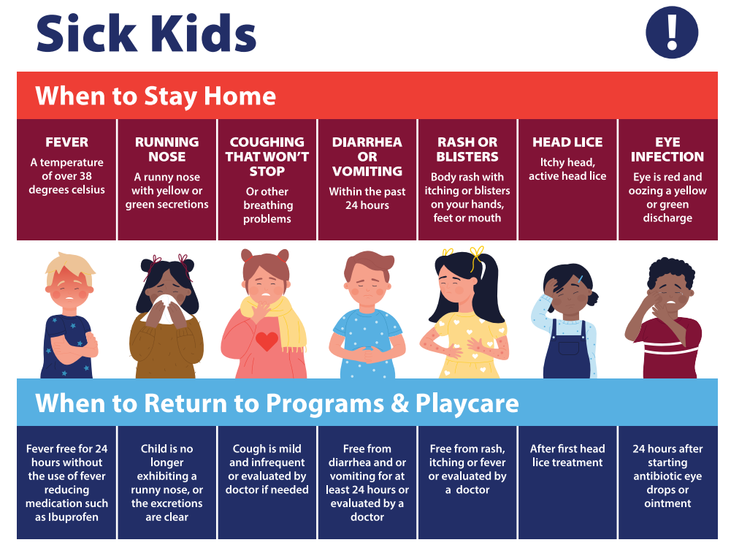

MEDICATIONS
Any required medications must be brought daily and remain in their original container. The label must clearly indicate the participant’s name, medication type, dosage, physician’s name, and any specific instructions staff need to be aware of.

In addition, a Medication Form must be completed and signed by the parent or caregiver prior to the administration of any medication. These forms are typically included in the program welcome email and are available at the sign in table.

Program staff are able to safely store medication for participants during program hours; however, staff are not

able to administer medication. Participants must be able to take and manage their own medication independently if needed.

ALLERGY AWARE PRACTICES
To help ensure the safety of all children, we ask that you do not send any food containing peanuts, peanut butter, peanut oil, or tree nuts.

Parents and caregivers are encouraged to include any known allergies or medical considerations during the registration process. This information will be visible on the program roster and may be updated by staff at any time as needed. Parents and caregivers will also be informed of any known allergies within the current program group as applicable.

Handwashing practices are encouraged and completed regularly throughout the program, particularly before and after eating, to help prevent cross-contamination.

Program Instructors monitor food brought to program to support the City’s “no food sharing” practice. When packing your child’s food, we ask parents and caregivers to carefully review ingredient labels and be mindful of potential allergens and cross-contamination. We also encourage families to support children in learning about food allergies and safe food practices.

City of Grande Prairie Program Instructors are trained to recognize and respond to suspected allergic reactions and related medical conditions. If a child shows signs of an allergic reaction, they will be cared for appropriately while staff contact the parent or guardian. In the event of a severe reaction, Program Instructors will call 911 immediately and follow the instructions provided by emergency services until help arrives.

INCLUSION AND SPECIAL REQUIRMENTS
The City of Grande Prairie is committed to providing an inclusive environment where all parents are welcome to register for our programs.

During the registration process, families are encouraged to include any helpful information regarding their child that may support their participation and overall experience. These notes are kept confidential; however, they allow our staff to better understand each child’s needs and, when appropriate, reach out prior to the program to discuss how we can help ensure a positive and successful experience.

Please also inform us of any prompts, strategies, or supports that may assist your child in participating fully. In some cases, an inclusive planning meeting may be scheduled to support the child’s success and determine appropriate supports.

While our goal is inclusive participation, there may be situations where a child requires additional support beyond what Program Instructors are able to provide. In these cases, Program Instructors reserve the right to request that a support person (such as a certified aide or parent/caregiver 18 years or older) accompany the child. If required, it is the responsibility of the parent/caregiver to arrange and provide this support person.

A meeting will be held between the parent/caregiver and the Program Coordinator to develop an individualized success plan tailored to the child’s needs. We encourage families to connect with the Program Coordinator or Supervisor at any time with questions or for additional information. In the event that an appropriate support person is not available, the City reserves the right to refuse service.

Contact information can be found on page 9.

GENDER IDENTITY AND EXPRESSION
The City of Grande Prairie programs aim to encourage each child to feel comfortable being themselves while participating in our programs. For more information on the legislation of Gender Identity and Expression please visit https://justice.gc.ca/.

CODE OF CONDUCT
A safe and welcoming environment is essential for supporting each child’s social, emotional, intellectual, and physical development. With this comes a shared responsibility to respect ourselves, others, the environment, and the community.

Within our programs, we support and encourage positive behaviour. Participants are expected to be respectful, cooperative, engaged, and positive throughout all programming. These expectations are also reinforced through signage posted during programs and camps for ongoing reference.

BEHAVIOR MANAGEMENT
All children who participate in The City of Grande Prairie Child and Youth Programs are treated in a positive manner that supports healthy development. Each child is respected and recognized in ways that protect their well-being, individuality, self-worth, and self-esteem.

Our programming team works closely with all children and encourages participants to follow direction and interact with others in a cooperative and respectful manner. If a child exhibits disruptive behaviour, staff will take the time to explain the concern, guide the child through expected behaviours, and provide opportunities for the child to express their thoughts and feelings. If the behaviour does not improve, the child may be separated from the group to calm down, reflect on their actions, and/or work toward finding a solution. Children will then be reminded of expectations and encouraged to reconnect with a Program Instructor before returning to the activity.

If a pattern of disruptive behaviour continues after support and guidance have been provided, the child will be given up to three chances to correct the behaviour, and caregivers will be informed throughout the process. After three chances have been issued, the child’s caregiver will be asked to pick up their child for the remainder of the day.

We reserve the right to withdraw a child from programming when the safety of the child, other participants, or staff is at risk. This decision is made at the discretion of the Program Coordinator and or Manager. This also includes situations where Alberta Health requirements are not being followed.

If disruptive behaviour continues, or if there are multiple acts of intentional aggression within a two-day period, the parent/caregiver may be asked to pick up their child for the day and may be required to keep the child home for a specified period of time, which can be up to 48 hours. Severe incidents may result in a suspension of up to six months from all City programming.

Parents/caregivers who are asked to keep their child home for up to 48 hours will be required to meet with the Program Coordinator and or Manager to discuss and implement a Behaviour Guidance and Reintegration Plan. Staff will work collaboratively with the parent/caregiver to discuss strategies, supports, and recommendations to encourage future success within the program.

Children who receive a suspension longer than 48 hours, up to six months, may be required to return to programming with additional support such as an aide, caregiver, or designated program support individual.
If disruptive behaviour continues after the child has participated in the Behaviour Guidance and Reintegration Plan, further steps will be determined at the discretion of the Manager.

City of Grande Prairie programs reserve the right to withdraw a child from programming when the safety of the child, other participants, or staff is considered at risk.

BULLYING PREVENTION & POSITIVE PARTICIPATION
The City of Grande Prairie is committed to providing a safe, welcoming, and inclusive environment where all participants feel respected, valued, and supported. We have a zero-tolerance approach to bullying in all City programs, camps, and activities.

Bullying may include, but is not limited to:
- Physical aggression or intimidation
- Verbal insults, teasing, or name-calling
- Social exclusion or intentionally leaving others out
- Threatening behaviour
- Harassment based on personal characteristics, abilities, gender identity, race, culture, religion, or other differences
- Cyberbullying that impacts the program environment

To help create a positive experience for everyone, program expectations are reviewed with participants and posted at each sign-in table and program location. Participants are expected to treat others with kindness, respect, and consideration at all times.

If bullying behaviour is observed or reported:
- Program staff will intervene immediately to ensure the safety and well-being of all participants.
- Staff will work with those involved to understand the situation, reinforce expectations, and support positive conflict resolution when appropriate.
- Parents/caregivers may be contacted regarding incidents of bullying or repeated negative behaviour.
- Ongoing or serious incidents may result in the participant being removed from activities for the day, required parent meetings, implementation of a behaviour support plan, suspension, or withdrawal from
- programming.

We encourage participants to speak with a Program Instructor if they feel uncomfortable, unsafe, or witness behaviour that does not align with our program expectations. Creating a positive environment is a shared responsibility, and we appreciate the support of families in reinforcing respectful behaviour both in and outside of our programs.

The City of Grande Prairie reserves the right to remove any participant whose behaviour compromises the safety, well-being, or positive experience of others.

AFTERHOURS PICK UP POLICY
City of Grande Prairie programs operate only during the scheduled hours outlined at the time of registration. We understand that unforeseen circumstances may occasionally occur; however, we ask that parents/caregivers notify the Program Instructor or Program Coordinator as soon as possible if they will be late picking up their child.

After a second late pick-up occurrence, a late fee of $10.00 per 5-minute increment will be applied. Continued late pick-ups or an ongoing pattern may result in removal from the program.

To notify programming staff of a late pick-up, please email programming@cityofgp.com or contact Access GP at 780-538-0300.

PROGRAM CANCELATION POLICY
The City retains the right to cancel, combine, or divide classes up to the date of the first session in a program. A full refund will be offered to the program participant.
· A program participant will receive a full refund on cancellation of Programming when the customer provides up to ten (10) Business Days’ notice prior to the first session in a
program.
· A program participant will receive a partial refund, equal to 50% of the programming
fees, when the program participant provides between five (5) to ten (10) Business Days
notice (120 to 240 hours) notice of cancellation.
· If cancellation notice is provided with less than five (5) Business Days’ notice (120
hours) prior to the commencement of the first session of Programming, no refund will be provided.

MEDICAL CIRCUMSTANCES
Withdrawals requested for medical reasons are subject to approval by a Program Coordinator and/or Manager. In some cases, a doctor’s note may be required to support the withdrawal request. Supporting documentation should typically be submitted within two weeks of the withdrawal notification.

PROGRAM CANCELLATIONS
Programs may be cancelled due to insufficient registration numbers. Participants will be notified as soon as a decision regarding cancellation has been made.
If the City cancels a program, participants will be eligible for a full refund or may transfer to another available program, space permitting. Please note that refunds may not be issued immediately; however, they will be processed in a timely manner.

FEEDBACK AND COMMENTS
The City of Grande Prairie programs strive to provide high-quality programming for your child. If you have any concerns about program content or would like to provide feedback, please contact us at programming@cityofgp.com as soon as possible.

A satisfaction survey is also distributed periodically throughout the year to gather feedback and support continuous improvement of our programs.

WHAT TO EXPECT IN CITY CHILD & YOUTH PROGRAMS
This section outlines what you can expect when participating in City programs at any of our locations. Some sites may have specific requirements, so we encourage families to carefully review all communication (including welcome emails and attachments) prior to attending.

45 Minutes to 2-HOUR PROGRAMS:
(Early Learning, Cooking Classes, Learn to Play, Parented Play, Active Play, etc.)

PRIOR TO ARRIVAL:
Please ensure your child is ready for their program. If they are experiencing flu-like symptoms or are unwell, please keep them at home.

A welcome email is sent out prior to the program starting, which includes additional important information specific to your child’s registered program. We encourage families to review this information carefully before attending and review any forms attached.

WHAT TO BRING:
For all 45 minutes to 1-hour programs, please bring:
- Refillable water bottle
- Appropriate clothing for movement and activity (indoor/outdoor as applicable)
- Indoor running shoes if required by the program

Please note clothing may become soiled during active play or hands-on activities.
Children must be fully toilet trained and independent prior to registration for programs for ages three and older. In the event your child’s program allows for snacks, ensure that it is nut free.

Purchasing food during program time from facility vendors or vending machines is not permitted. Food and snack sharing between participants is also strictly prohibited.

ARRIVAL & PICK-UP:
- Please follow all posted signage upon arrival
- Allow extra time for drop-off and pick-up
- Children must be signed in and out each time by a parent/caregiver
- Please arrive on time, as children may move to other areas of the facility once the program begins

If you arrive late or need early pick-up, please check in with Guest Services, refer to posted program signage, or contact the Program Supervisor or Coordinator.

DAY CAMPS:

PRIOR TO DROP-OFF:
Please ensure your child is ready for the day. If they are experiencing flu-like symptoms or are unwell, please keep them at home.

WHAT TO BRING:
Please pack the following daily:
- Refillable water bottle
- Large, healthy, nut-free snacks and lunch
- Indoor and outdoor running shoes
- Weather-appropriate clothing for active play

Additional items (as outlined in welcome communication or activity calendar):
- Eastlink Centre Swim Camps: swimwear, googles and towel
- Summer camps: sunscreen, bug spray (in a labeled Ziploc bag), and a hat
- Skating programs: CSA-approved helmet, skates, and warm outdoor clothing

Children must be fully toilet trained and independent prior to registration for programs for ages three and older.

Purchasing food during program hours from facility vendors or vending machines is not permitted. Food and snack sharing between participants is also strictly prohibited.

ARRIVAL & SIGN-IN:
- Please follow all signage and staff direction
- Allow extra time for drop-off and pick-up
- All children must be signed in upon arrival (mandatory)
- Please ensure your child is dressed appropriately for outdoor activities, as programs may go outside

At the beginning of the program, families may speak with instructors and review the daily schedule. The Parent Handbook will be included in the welcome email, and QR code at the sign in table.

Each child will have a designated space for belongings. Labeled items help ensure easy identification. Please leave valuables at home, as electronic devices are not permitted. City staff are not responsible for lost or stolen items.

DURING CAMP:
Programs include a balance of structured and unstructured activities, both indoors and outdoors as weather permits.

Children’s health and well-being are monitored throughout the day. Staff follow strict hygiene and safety practices to support a safe environment for all participants. If you are unsure if you should send your child, please refer to page 3.

PICK-UP:
- Please follow all posted signage before approaching the program area
- Children must be signed out directly with Program Instructors (mandatory)
- This process is required for safety and accurate attendance tracking
- Ensure your child has all of their belongings

ACKNOWLEDGEMENT OF RISK
By registering, the participant and/or parent/caregiver acknowledges and accepts the inherent risks associated with participation in recreational programs and services. This includes the possibility of physical injury that may occur despite safety measures being in place and waives any claim for injury arising from participation.

Participants are expected to follow all safety instructions, guidelines, and directions provided by program staff and/or instructors. Where applicable, participants are also expected to use appropriate protective equipment as required by the program or activity.

If you have any questions or would like more information about the specific risks associated with a program or activity your child is registered in, please contact the Program Coordinator and/or Program Supervisor prior to participation.

PRIVACY STATEMENT (POPA)
Personal information is collected under the authority of section 4(c) of the Protection of Privacy Act, SA 2024, c. P-28.5 (“POPA”), as it is directly related to and necessary for the administration and delivery of City programs, activities, facilities, and services, including registration, safety and risk management, emergency response, and communication with participants and legal guardians.

The City collects, uses, and discloses personal information in accordance with POPA and the Access to Information Act, SA 2024, c. A-1.4 (“ATIA”), and will take reasonable steps to protect personal information and only disclose it as authorized by law.

For questions about the collection, use, or disclosure of personal information, or to request access to or correction of personal information, please contact the programming department: programming@cityofgp.com.

RECEIPTS
The City of Grande Prairie no longer issues receipts for tax purposes. Please ensure you keep the receipt provided to you at the time of registration for your records.

PROGRAM COORDINATOR & MANAGER

Name | Position | Phone Number | Email
Ashleigh Wills | Manager, Active Living | 780-357-4998 | programming@cityofgp.com
Brittany Bell | Program Coordinator | 780-830-7076 | programming@cityofgp.com
Kaeli Fraser | Program Coordinator | 780-830-7086 | programming@cityofgp.com

PROGRAM LOCATIONS MAY INLCLUDE:
Keyera Place, Eastlink Centre, Ernie Radbourne Pavilion, CKC Grande Stands, Dave Barr Community Centre, Fossil Energy Ball Park, South Bear Creek Bike Park, Grande Prairie Museum, Maude Clifford Community Gym, Mother Teresa Community Gym, Design Woks Centre, Crystal Lake Pond, and Lions Splash Park.

PROGRAM FAQ’s
What can my child expect to be doing in the program or camp?
Structured and unstructured play activities are alternated throughout the program and can be adapted to ensure all participants are able to take part. Activities may include, but are not limited to, swimming, skating, outdoor and indoor active play, arts and crafts, visits to neighbourhood playgrounds and parks, baking, cooking, engineering challenges, and science experiments.

Swimming Pool Safety & Supervision
During transitions to the pool, participants will be permitted to use the family change room with supervision. Program Instructors will change prior to swimming or after all children have changed. Life jackets are available on deck at the Eastlink Centre.

Participants at a Level 4 skill level or higher will not be required to wear a life jacket in the pool. A swim assessment may be requested, subject to lifeguard availability, and may be completed each swim day.

- Children aged 6–7 will follow a supervision ratio of 1:3 with a designated Program Instructor and are required to wear a life jacket unless they have successfully passed a swimming test on that day.

- Children aged 8–12 will stay together as a group and supervised by a Program Instructor while in the swimming pool. They are not permitted to wander independently in the pool area or leave their group, even if friends or family are present.

I need to drop off my child late today or pick them up early today. Where can I find my child?
- Please ensure you have emailed programming@cityofgp.com in advance
You are still required to sign your child in or out following standard procedures
If your child is in the pool area, please ensure you have pre-arranged an early pick-up. Please meet them at the programming room for pick-up. A Program Instructor will assist in retrieving their dry clothing from the group locker area

Is it possible to have someone other than myself pick up or drop off my child(ren)?
- Under the guidelines set out by the Government of Alberta, a designated parent/caregiver for pick-up and drop-off of the child(ren) is preferred.

- If you require an alternate person to pick up or drop off your child(ren), please contact the Program Coordinator prior to the scheduled arrangement, or immediately in the event of an emergency, and email programming@cityofgp.com to confirm details.

I am excited to hear about my child’s day; how can I get this information?
- A Program Instructor is happy to provide an update at the sign-in/sign-out table, or you may contact the Program Supervisor or Coordinator to receive an update, share concerns, or ask questions.

- Due to privacy legislation (POPA), we are unable to take or share photos of participants.
- Due to supervision requirements and program delivery, staff are not able to provide text or email updates throughout the day, unless it is related to an emergency or behavioural circumstance.

My child has lost or is missing belonging?
- Lost or forgotten items will be stored in the facility’s main Lost and Found on the last day of the program.
- Clearly labelled items are easier to identify and return to their owner. Program Instructors are not responsible for lost or stolen items.
- Please keep valuables and electronics at home.

Weather Considerations
Outdoor play is an important part of many of our programs and camps. Staff monitor weather conditions on an ongoing basis and may adjust activities as needed to support participant safety and comfort.

Programs may be moved indoors, shortened, modified, or cancelled due to factors such as extreme weather, lightning, poor air quality, or other environmental conditions.

The City monitors both the Air Quality Health Index (AQHI) and UV Index. Outdoor activities may be modified when the AQHI reaches 7 or higher or when the UV Index reaches 7 or higher.

Each situation is assessed individually based on the activity, participant ages, location, and available resources. In some cases, programs may continue outdoors when immediate access to drinking water, shade, cooling areas, and appropriate supervision is available.

Please ensure your child arrives dressed appropriately for the weather and has any required seasonal items, such as sunscreen, a hat, rain gear, or warm outdoor clothing.

Program schedules and activities may change without notice due to weather or environmental conditions to help ensure the safety and well-being of all participants and staff.

Handbook Summary
We are committed to providing a safe, inclusive, and engaging environment where children can learn, play, and grow. This handbook is intended to support families by outlining expectations, procedures, and important information to help ensure a smooth and positive program experience.

We encourage you to review this information prior to your child’s participation and refer to it as needed. If you have any questions or require clarification, please do not hesitate to contact our team at programming@cityofgp.com.

Thank you for choosing City of Grande Prairie Child and Youth Programs. We look forward to welcoming your child into our programs.

